Name

Date Pd

Chemistry – Unit 1 Review

1. What is the difference between mass of an object and its volume?

2. If the box at left contains atoms of aluminum in the liquid phase, represent the same atoms in the solid phase in the box at right.
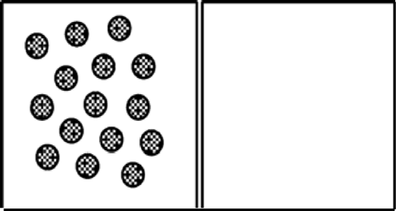

3. How would you represent the atoms of aluminum in the gaseous phase?

4. If the box at left contains atoms of iron in steel wool, represent the atomic structure of the steel wool after strong heating in the box at right.
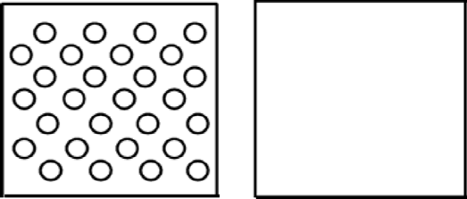

5. The 7th period chemistry class produced the histogram below to represent the change in mass when sugar was dissolved in water.
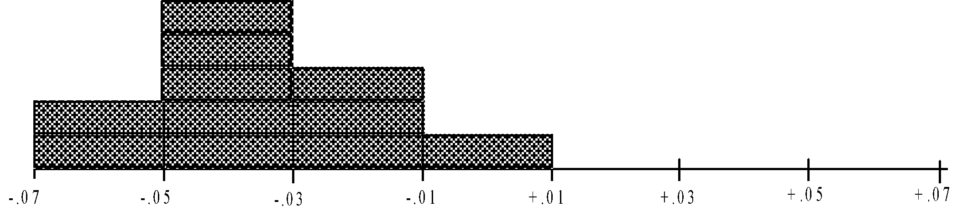
They concluded that the mass decreases slightly when sugar dissolves. Provide a better explanation.

6. The 9th Hr chemistry class produced the following graph when they were measuring the mass and volume of a set of objects in the lab.
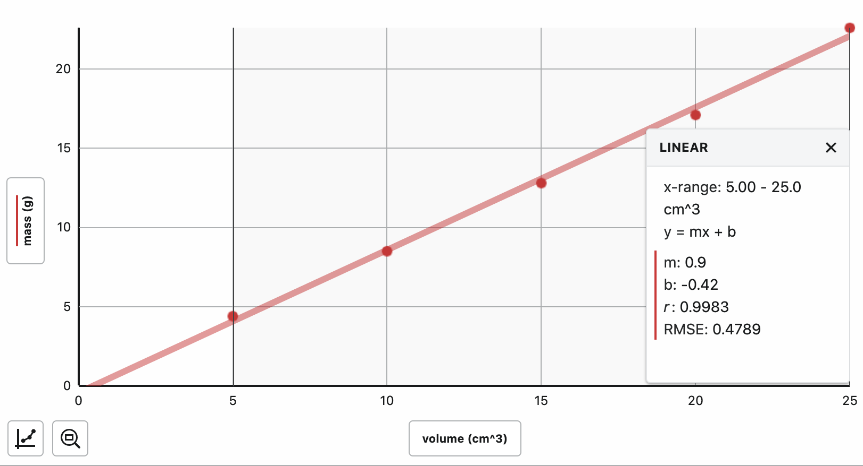

a. Write the equation for the line.

b. What information is given by the slope of the graph?

c. Is the y-intercept negligible? Why or why not?

d. What would you predict would happen if you were to put one of the objects in water? Explain.

e. What would you expect to be the mass of a 45 cm³ piece of the same substance?

Density Problems

7. Mercury has a density of 13.6 g/mL. What is the volume occupied by 112.0 grams of mercury?

8. A cube of gold-colored metal with a volume of 54 cm³ has a mass of 980 g. The density of gold is 19.3 g/cm³. Is this sample of metal pure gold? Why or why not?

